《数据结构》实验报告
实验序号：2 实验项目名称：顺序表的实现
学 号 |  | 姓 名 |  | 专业、班级
实验地点 |  | 指导教师 |  | 实验时间
一、实验目的及要求
1.掌握线性表的顺序存储类型；
2.熟练掌握顺序表的基本操作和具体的函数实现。
二、实验设备（环境）及要求
微型计算机；
windows 操作系统；
Microsoft Visual Studio 6.0集成开发环境。
三、实验内容与步骤
1.设A、B均为用数组实现的List类型的顺序表，试设计一个函数Alternate（A,B），从表A中第1个元素开始，交替地用表A和表B中元素组成一个新表。

2.顺序表表示和实现线性表的如下：
# define LIST_INIT_SIZE 10
# define LISTINCREMENT 5
typedef struct{
ElemType *elem;
int length ;
int ListSize;
} sqlist;

int InitList_sq(sqlist *l) /*initial the list l*/
{
l->elem=(ElemType *)malloc(LIST_INIT_SIZE*sizeof(ElemType));
if (!l->elem)
{
printf("无法分配空间！");
return 1;
}
else
{
l->length=0;
l->ListSize=LIST_INIT_SIZE;
printf("ok");
return 0;
}
}
void main()
{
sqlist L;
……
InitList_sq(&L);
……
}
【要求】1、实现顺序表的插入、删除、按值查找等基本操作；
2、假设构建的是非递增有序顺序表，设计算法实现从该有序顺序表中删除所有其值重复的元素，使得表中所有元素的值均不同。

四、实验结果与数据处理
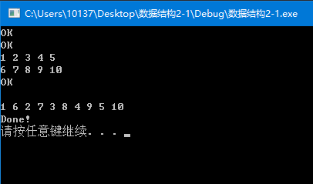
2-1

2-2
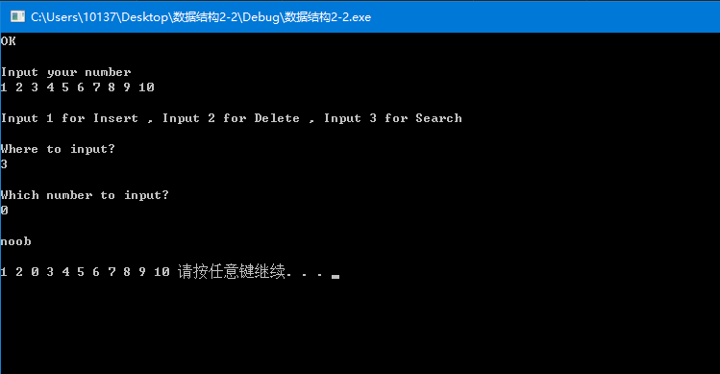
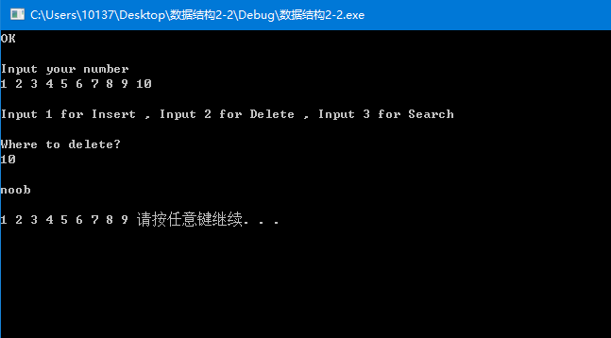

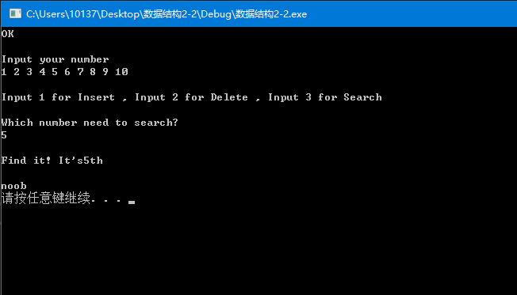

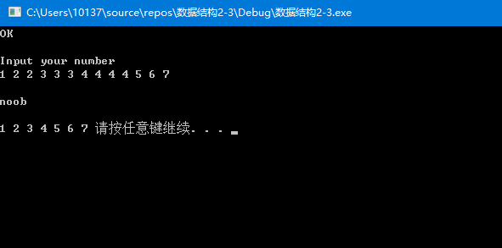
2-3
五、分析与讨论
对上机实践结果进行分析，上机的心得体会。
五、教师评语  签名：  日期： |  |  |  |  | 成绩
附源程序清单：
1.
// 数据结构2-1.cpp: 定义控制台应用程序的入口点。
//

#include "stdafx.h"
#include "iostream"
#include "cstdio"
# define LIST_INIT_SIZE 10
# define LISTINCREMENT 5
typedef struct {
int *elem;
int length;
int ListSize;
} sqlist;

int InitList_sq(sqlist *l) /*initial the list l*/
{
l->elem = (int *)malloc(LIST_INIT_SIZE * sizeof(int));
if (!l->elem)
{
std::cout << "无法分配空间！\n";
return 1;
}
else
{
l->length = 0;
l->ListSize = LIST_INIT_SIZE;
std::cout << "OK\n";
return 0;
}
}
void Alternate(sqlist *A, sqlist *B)
{
sqlist list, *C;
C = &list;
InitList_sq(C);
C->length = A->length + B->length;
for (int i = 0; i < 5; i++)
{
C->elem[2 * i] = A->elem[i];
C->elem[2 * i + 1] = B->elem[i];
}
for (int i = 0; i < C->length; i++)
{
std::cout << C ->elem[i];
}
std::cout << "\nDone!\n";
}
void main()
{
sqlist list1, list2, *A, *B;
A = &list1;
B = &list2;
InitList_sq(A);
InitList_sq(B);
A->length = 5;
B->length = 5;
for (int i = 0; i < 5; i++)
std::cin >> A->elem[i];
for (int i = 0; i < 5; i++)
std::cin >> B->elem[i];
Alternate(A,B);

system("pause");
}

2.
// 数据结构2-2.cpp: 定义控制台应用程序的入口点。
//

#include "stdafx.h"
#include "iostream"
#include "cstdio"
#include "conio.h"
#include "stdlib.h"
# define LIST_INIT_SIZE 10
# define LISTINCREMENT 5
typedef struct {
int *elem;
int length;
int ListSize;
} sqlist;

int TestListSize(sqlist *str)
{
if (str->length >= str->ListSize)
{
int *newbase = (int *)realloc(str->elem, (str->ListSize + LISTINCREMENT) * sizeof(int));
if (!*newbase)
{
std::cout << "Uable to allocate the required memory!\n";
return 0;
}
else
{
str->elem = newbase;
str->ListSize++;
}
}
return 1;
}

int InitList(sqlist *str) /*initial the list l*/
{
str->elem = (int *)malloc(LIST_INIT_SIZE * sizeof(int));
if (!str->elem)
{
std::cout << "Unable to allocate the required memory！\n";
return 1;
}
else
{
str->length = 0;
str->ListSize = LIST_INIT_SIZE;
std::cout << "OK\n";
return 0;
}
}

int InsertList(sqlist *str, int where, int number)
{
if (where < 1 || where > str->length + 1)
return 0;
TestListSize(str);
for (int i = str->length + 1; i >= where; i--)
{
str->elem[i] = str->elem[i - 1];
}
str->length++;
str->elem[where - 1] = number;
return 1;
}
int DeleteList(sqlist *str, int where)
{
if (where < 1 || where > str->length)
{
std::cout << "Out of the memory";
return 0;
}
/*
for(int i = where-1; i <str->length-1 ;i++)
{
str->elem[i]=str->elem[i+1];
}*/
//***************
int *l = &str->elem[where - 1];
int *r = &str->elem[str->length - 1];
for (; l < r; l++)
*l = *(l + 1);
//***************
str->length--;
return 1;
}
int SearchList(sqlist *str, int number)
{
for (int i = 0; i<str->length; i++)
{
if (str->elem[i] == number)
{
std::cout << "\nFind it! It's" << i + 1 << "th\n";
return 1;
}
}
std::cout << "\nI can't find it\n";
return 0;
}

int main()
{
sqlist list, *l;
l = &list;
InitList(l);
std::cout << "\nInput your number\n";
for (int i = 0;; i++)
{
std::cin >> l->elem[i];
l->length++;
if (l->length >= l->ListSize) TestListSize(l);
if (getchar() == '\n')break;
}
std::cout << "\nInput 1 for Insert , Input 2 for Delete , Input 3 for Search\n";
char ch;
do
{
ch = _getch();
if (ch == '1')
{
int where, number;
std::cout << "\nWhere to input?\n";
std::cin >> where;
std::cout << "\nWhich number to input?\n";
std::cin >> number;
if (InsertList(l, where, number))std::cout << "\nnoob\n\n";
for (int i = 0; i < l->length; i++)
std::cout << l->elem[i] << " ";
break;
}
else if (ch == '2')
{
int where;
std::cout << "\nWhere to delete?\n";
std::cin >> where;
if (DeleteList(l, where))std::cout << "\nnoob\n\n";
for (int i = 0; i < l->length; i++)
std::cout << l->elem[i] << " ";
break;
}
else if (ch == '3')
{
int number;
std::cout << "\nWhich number need to search?\n";
std::cin >> number;
if (SearchList(l, number))std::cout << "\nnoob\n";
break;
}
} while (ch != '1' || ch != '2' || ch != '3');
system("pause");
return 0;
}

3. // 数据结构2-2.cpp: 定义控制台应用程序的入口点。
//

#include "stdafx.h"
#include "iostream"
#include "cstdio"
#include "conio.h"
#include "stdlib.h"
# define LIST_INIT_SIZE 10
# define LISTINCREMENT 5
typedef struct {
int *elem;
int length;
int ListSize;
} sqlist;

int TestListSize(sqlist *str)
{
if (str->length >= str->ListSize)
{
int *newbase = (int *)realloc(str->elem, (str->ListSize + LISTINCREMENT) * sizeof(int));
if (!*newbase)
{
std::cout << "Uable to allocate the required memory!\n";
return 0;
}
else
{
str->elem = newbase;
str->ListSize++;
}
}
return 1;
}

int InitList(sqlist *str) /*initial the list l*/
{
str->elem = (int *)malloc(LIST_INIT_SIZE * sizeof(int));
if (!str->elem)
{
std::cout << "Unable to allocate the required memory！\n";
return 1;
}
else
{
str->length = 0;
str->ListSize = LIST_INIT_SIZE;
std::cout << "OK\n";
return 0;
}
}
int CheckInDuplicate(sqlist *str)
{
for (int i = 0; i < str->length-1; i++)
{
if (str->elem[i] == str->elem[i + 1])
{
//std::cout <<str->elem[i]<< "\nFuck"<< str->elem[i + 1];
for (int j = i; j < str->length - 1; j++)
{
str->elem[j] = str->elem[j + 1];
}
str->length--;
i--;
}
}
std::cout << "\nnoob\n\n";
return 1;
}

int main()
{
sqlist list, *l;
l = &list;
InitList(l);
std::cout << "\nInput your number\n";
for (int i = 0;; i++)
{
std::cin >> l->elem[i];
l->length++;
if (l->length >= l->ListSize) TestListSize(l);
if (getchar() == '\n')break;
}
//std::cout << l->length << std::endl << l->ListSize;
CheckInDuplicate(l);
for (int i = 0; i < l->length; i++)
std::cout << l->elem[i] << " ";
system("pause");
return 0;
}

